**Assignment – 1**

 

1. Install Power BI Desktop and share the final screenshot of the report view page which appears when power desktop starts.

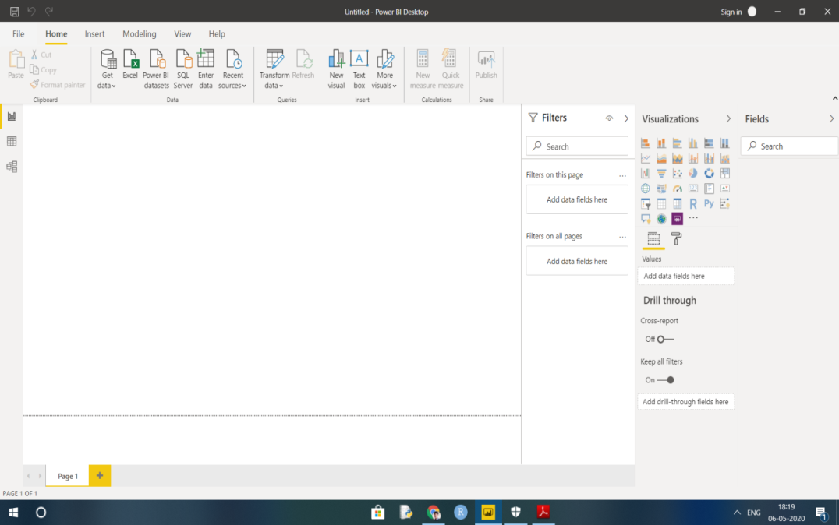

1. Prepare a document and with the following screenshot

− Report View

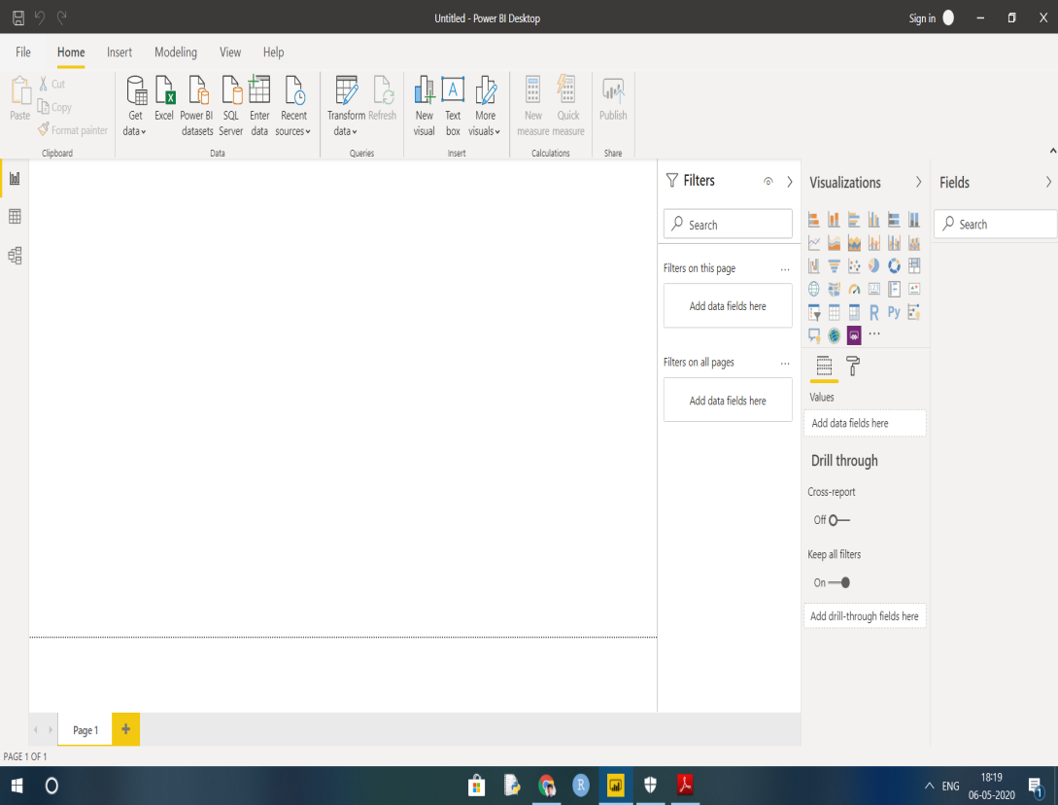

− Data View

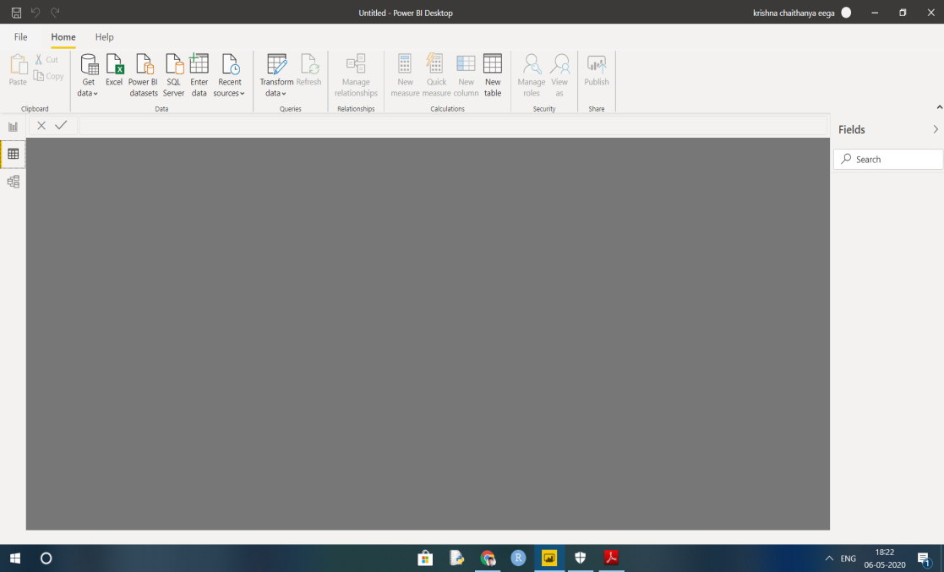

− Model View

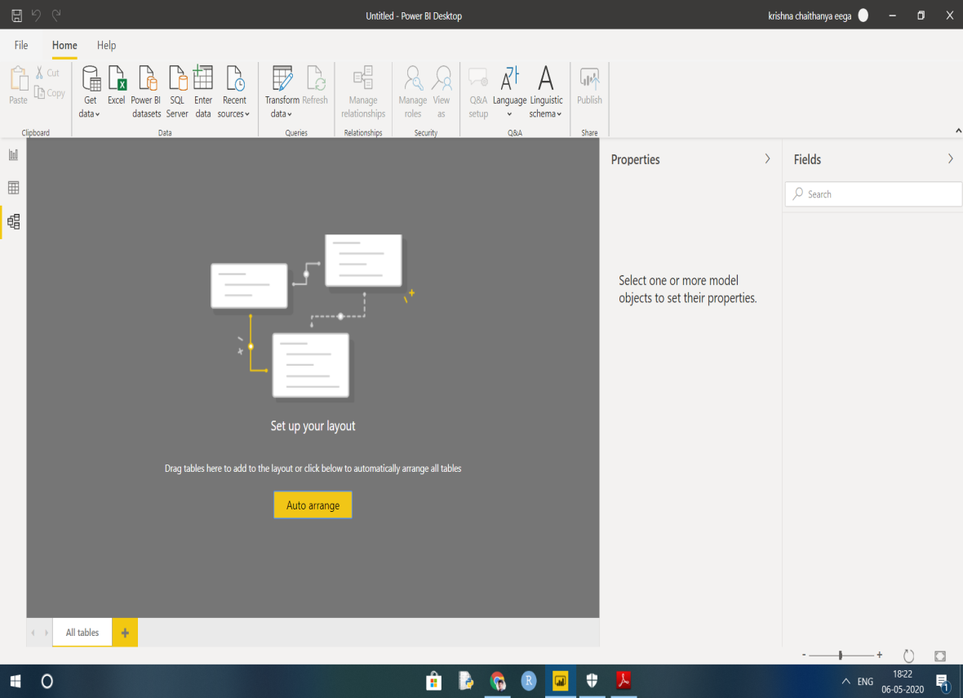

− Power Query Editor

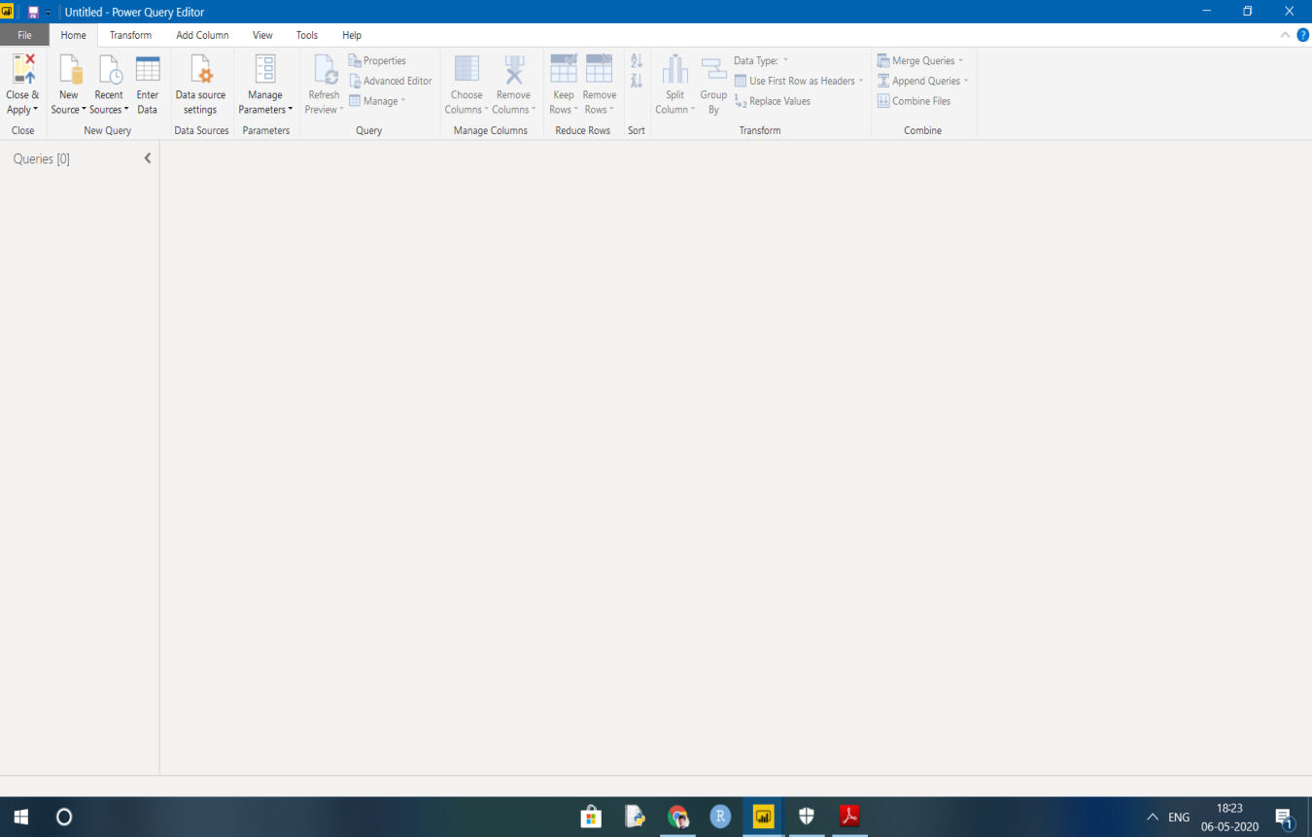

− Advance Editor

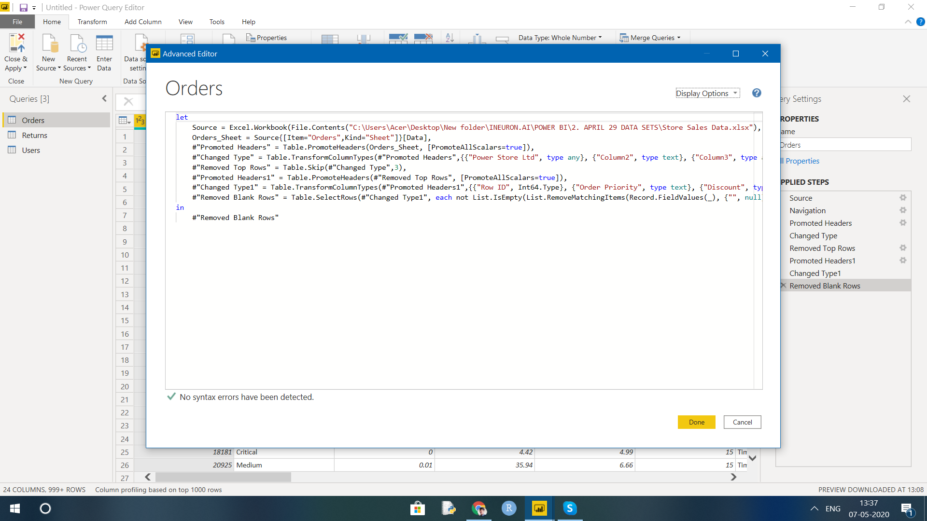

1. Prepare a document with details of the following along with their price
   * Power BI Desktop

This offering is free to any single user and includes data cleaning and preparation, custom visualizations and the ability to publish to the Power BI service. **Power BI Desktop** is a free application you install on your local computer that lets you connect to, transform, and visualize your data.This data model lets you build visuals, and collections of visuals you can share as reports, with other people inside your organization.

**Price :** 0

* + Power BI Pro

with **Pro** you can share your data, reports, and dashboards with other users who also have a **Power BI Pro** license. You can also create App workspaces. Both **Power BI** Free and **Pro** have a 10 GB per **Pro** user data storage limit.

**Price :** **$9.99**/user/month.

* + Power BI Premium

For larger organizations, **Power BI Premium** may be best option. While **Power BI Pro** is an individual license, **Premium** is an enterprise **BI** platform for everyone in your organization. **Premium** offers dedicated capacity to deliver more consistent performance and support larger data volumes in **Power BI**.

**Price:** $4,995 Monthly price per dedicated cloud compute and storage resource with annual subscription